**Govt. Post Graduate College of Science**



**Final Project Proposal Guide**

**Version 1.0**

Table of Contents

1 Introduction 4

1.1 Project Title 4

1.2 Project Overview Statement Template 4

1.3 Project Goals & Objectives 5

1.4 High Level System Component 5

1.5 List Of Optional Functional Units 5

1.6 Exclusions 6

1.7 Application Architecture 6

1.8 Gantt Chart 7

2.1 System Component Details 9

2.1.1 Registration 9

2.1.2 Login 10

2.1.3 Dashboard 10

2.1.3 Dashboard Visualizations- Charts 11

2.1.4 Add Expense 11

2.1.5 Manage Expenses 12

2.1.6 Update Expense 12

2.1.7 Delete Expense 12

2.1.8 Expense Report 13

2.1.9 Update Profile 13

2.2 Prototypes 14

2.2.1 Registration 14

2.2.2 Login 14

2.1.3 Dashboard 15

2.1.3 Dashboard Visualizations- Charts 15

2.1.4 Add Expense 16

2.1.5 Manage Expenses 17

2.1.6 Update Expense 17

2.1.7 Delete Expense 18

2.1.8 Expense Report 18

2.1.9 Update Profile 19

# Introduction

# Project Title

**ExpenseHub Web Application**

# 1.2 Project Overview Statement Template

|  |
| --- |
| **PROJECT TITLE:**  **ExpenseHub Web App** |
| **GROUP LEADER:**  Shiza Malik |
| **PROJECT MEMBERS:**   |  |  | | --- | --- | | NAME | ROLL NUMBER | | SHIZA MALIK | 3215/459875 | |
| **PROJECT GOAL:**  The main goal of ExpenseHub is to provide users with a simple and efficient way to track their personal finances, including income and expenses. By categorizing transactions and offering budget management features, the app helps users monitor their financial health and spending habits. |
| **OBJECTIVES:**  The primary objective of ExpenseHub is to deliver an intuitive solution that enables users to effectively manage their personal finances by tracking expenses and income, organizing transactions into categories, and establishing budget limits. |
| **PROJECT SUCCESS CRITERIA:**  The success of ExpenseHub will be measured by its ability to provide users with an intuitive, secure, and efficient platform for tracking their income and expenses. The app must accurately categorize transactions, generate insightful reports, and deliver timely budget alerts. |
| **RISKS AND OBSTACLES:**   * Time constraint due to university work load * A risk to meet user’s satisfaction as users have different requirements that are not feasible to implement all in one. * Difficulty in learning new technologies. |
| **TYPE OF PROJECT:**  Development |
| **TARGET END USERS:**  Admin and Users (Professionals, Students) |
| **DEVELOPMENT TECHNOLOGY:**   * HTML, CSS, JS and JQuery * PHP * MySQL |
| **PLATFORM:**  Web-based application |
| **PROJECT SUPERVISOR:**  Faiza Batool |
| **APPROVED BY:** |
| **DATE:** |

# 1.3 Project Goals & Objectives

The primary goal of ExpenseHub is to offer a user-friendly platform that allows individuals to efficiently manage their personal finances by tracking income and expenses. The app aims to help users categorize transactions, set budget limits, and receive insights into their spending habits. It seeks to provide users with clear, actionable financial reports for better decision-making. Ensuring data security and delivering a smooth, responsive user experience are key objectives. Ultimately, the app aims to empower users to maintain greater control over their financial well-being.

# 1.4 High Level System Component

Following are the high-level system components of this application:

* Registration
* Login
* Dashboard
* Add Expense
* Search Expense
* View Expense details
* Update/Delete Expense
* Expense Report
* Expense Graphs
* Update Profile
* Logout

# 1.5 List Of Optional Functional Units

Following are the optional features that we might implement according to availability of time:

* Implement google Auth2. Flow
* Mob Application for “ExpenseHub”

# 1.6 Exclusions

Exclusions are description of tasks that we are not including in our project scope. These exclusions are:

* Expense Split between multiple people module will not be included because of time constraint, resources and real time issues.

# 1.7 Application Architecture

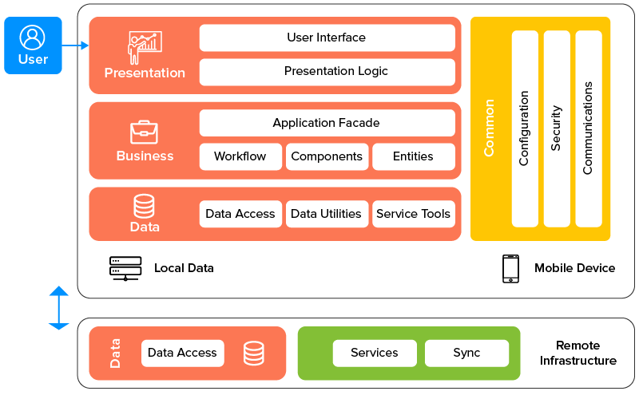

# 1.8 Gantt Chart

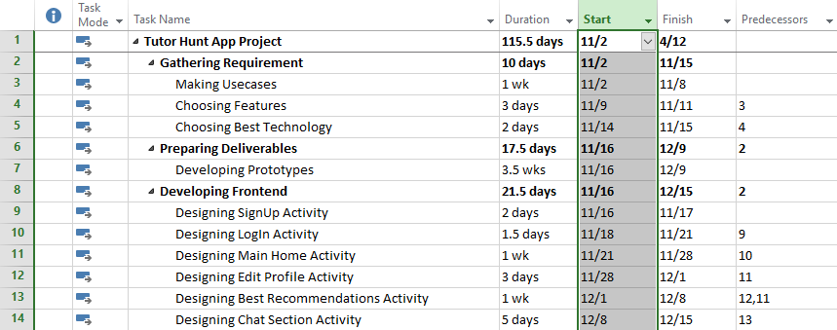

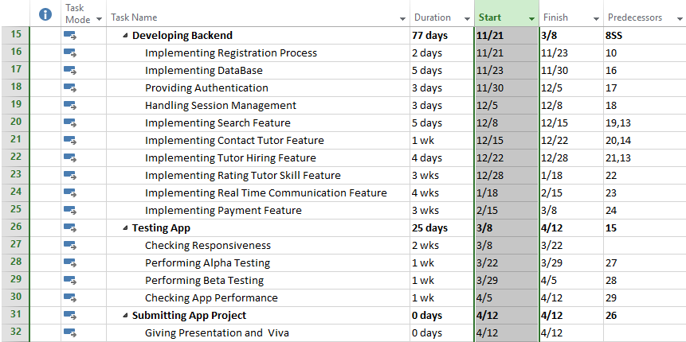

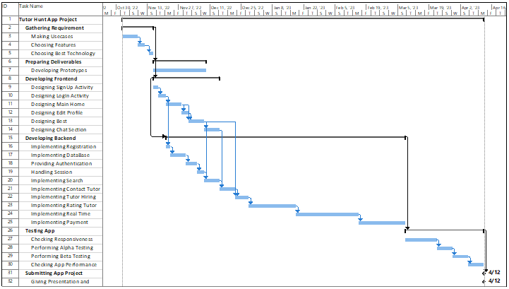

**1.9 Hardware and Software Specification**

**Hardware**

* Laptop or desktop with medium specifications
* Android mobile phone with new generations

**Software**

* Web browser

**1.10 Tools and Technologies used with reasoning**

**Technologies**

* HTML / JSX for general UI purposes
* CSS for designing purposes
* JS for some dynamic operations
* Php
* MySQL

**Tools**

* VS Code --- IDE for coding
* Browser inspection window tool for little design manipulations testing
* Apache Tomcat
* XAMP
* Heroku --- For deployment
* GitHub Desktop for Version control system

# 2.1 System Component Details

* Registration
* Login
* Dashboard
* Add Expense
* Search Expense
* View Expense details
* Update/Delete Expense
* Expense Report
* Expense Graphs
* Update Profile
* Logout

# 2.1.1 Registration

The registration component allows new users to create an account by providing their full name, email and password. It includes input validation for proper email format and password confirmation to ensure data accuracy and security. Additionally, it contains a link to redirect existing users to the login page, enhancing the overall user experience.

**Registration Screen Features:**

**Full Name Field:** Input field for users to enter their full name.

**Email Address Field:** Input field for users to provide a valid email address for account creation.

**Password Field:** Input field for users to create a secure password, typically with requirements such as a minimum length or special characters.

**Confirm Password Field:** Ensures users correctly enter and confirm their chosen password to prevent typing errors.

**Registration Button:** A button labeled "Register" to submit the form and create the account.

**Login Redirection Link:** A link that directs existing users to the login page if they already have an account.

**Form Validation:** Real-time validation for all fields, ensuring proper email format and password matching before the form can be submitted.

# 2.1.2 Login

The login screen for provides a simple and intuitive interface for users to access their accounts. It includes two input fields for the user to enter their email address and password. Once the credentials are provided, the user can click the Login button, which triggers the authentication process.

In case the user does not have an account, there is a **"Register Here"** link, which redirects them to the registration page. The layout is clean, with a prominent login button in green to encourage user interaction, and the registration link highlighted in red for easy access to sign up.

The login form is also equipped with basic validation to ensure all fields are filled before submission, enhancing both usability and security.

# 2.1.3 Dashboard

The ExpenseHub dashboard provides a comprehensive overview of the user's financial activities after login. It serves as the main hub where users can monitor their spending habits and track expenses. Below are the key components and features of the dashboard:

**User Profile Section:** Located on the left sidebar, displaying the user's profile picture, name, and email address for easy identification and personalization.

**Toggle Sidebar Button:** Collapses or expands the left navigation menu, allowing users to switch between a full-page dashboard view and the standard view with sidebar access.

**Navigation Menu:**

**Dashboard:** Directs users back to the main dashboard.

**Add Expenses:** Allows users to add new transactions for both income and expenses.

**Manage Expenses:** Provides a detailed view and management options for all recorded transactions.

**Expense Report:** Displays visual and tabular reports of expenses for detailed analysis.

**Profile:** Access to user profile settings.

**Logout:** A quick link to log out of the application securely.

**Expense Summary:**

**Today's Expense:** Shows the total amount spent today.

**Yesterday's Expense:** Displays the amount spent the previous day.

**Last 7 Days' Expense:** Shows the total amount spent over the last 7 days.

**Last 30 Days' Expense:** Displays the total amount spent in the past 30 days.

**Current Year Expense:** Shows the accumulated total expense for the current year.

**Total Expense:** Summarizes the user's overall expenses across all time periods.

# 2.1.3 Dashboard Visualizations- Charts

The ExpenseHub dashboard offers users four key visualizations to track and analyze their spending habits. A line chart shows daily expenses over the past week, helping users spot spending trends, while a bar chart categorizes monthly expenses, making it easy to identify areas with the highest spending. A second line chart displays monthly expenses over the past year, revealing fluctuations in spending patterns, and a yearly bar chart compares total spending across multiple years, providing insights into long-term financial trends. Together, these charts empower users to make informed decisions for better budget management.

**Dashboard Visualizations - Charts**

This section of the ExpenseHub dashboard provides users with insightful visualizations of their spending habits. There are four primary charts that help users analyze their expenses over time and across different categories:

**Daily Expenses (Line Chart):**

The line chart on the left illustrates the user's expenses over the past week. Each point on the graph corresponds to the total expense recorded on a specific day. The y-axis represents the amount spent, while the x-axis displays the dates. This visual helps users quickly spot trends in their spending patterns, such as any spikes or declines in daily expenses.

**Expense by Category (Bar Chart):**

The bar chart on the right breaks down the user's spending by category over the past month. Each bar represents a different category of expenses (e.g., Clothing, Entertainment, Food, Medicine), with the height of the bar corresponding to the total amount spent in that category. This chart allows users to easily identify where they are spending the most money, providing a helpful tool for budget management.

**Monthly Expenses (Line Chart):**

The chart on the left shows the user's monthly expenses for the past year. The x-axis represents the months, while the y-axis shows the amount spent in each month. The orange line graph connects the monthly data points, offering a clear visual of spending trends across the year. Users can easily identify fluctuations in their monthly spending, helping them assess months where they overspent or saved more. This chart provides insight into how the user's expenses have evolved throughout the year, allowing for more detailed financial planning.

**Yearly Expenses (Bar Chart):**

The chart on the right breaks down the user's total spending by year. Each bar represents a year, with the height of the bar corresponding to the total amount spent in that year. The different colored bars (red, green, blue, yellow, etc.) represent different years, helping users compare their financial activity across multiple years. This chart enables users to see how their spending has changed over time, giving them an overview of long-term financial trends.

# 2.1.4 Add Expense

The "Add Your Daily Expenses" form allows users to easily input and record their daily expenses by entering the amount, selecting the date, and choosing a category.

**Enter Amount Field:**A text input field where users enter the amount of the expense they want to record. This is the primary field for capturing the monetary value of the transaction.

**Date Field:** A date picker input where users can select the date of the expense. The default is set to the current date, but users can modify it to record past expenses if necessary.

**Category Dropdown:** A dropdown menu that allows users to select the category under which the expense falls. Categories could include options such as Food, Medicine, Entertainment, and others.

**Add Expense Button:** A button labeled "Add Expense" which submits the form once the user has entered all necessary details. Upon submission, the expense is recorded and added to the user’s list of expenses.

# 2.1.5 Manage Expenses

The "Manage Expenses" page allows users to view, edit, and delete their recorded expenses in an organized table format. Users can sort the expenses by different criteria like Recently Added, Month, Category etc. and manage each entry by adjusting details or removing it entirely. This functionality provides users with full control over their expense records, ensuring accuracy and ease of management.

**Sorting Option:** At the top of the table, users can sort expenses using a dropdown menu, with options such as Recently Added, Month, Category etc. to change the order of displayed records.

**Expense Table:** Displays the serial number, date, amount, category of each expense for easy reference.

**Edit and Delete Options:** Each expense entry includes an option to edit the details of that expense or delete it entirely, giving users control over maintaining accurate records.

# 2.1.6 Update Expense

The "Update Expense" page allows users to modify their previously recorded expenses, including the amount, date, and category. It is accessed via the Edit button on the "Manage Expenses" page. After making changes, users can save the updates by clicking the Update button.

**Enter Amount Field:** Displays the current amount of the expense, which the user can modify as needed.

**Date Field:** Shows the date of the recorded expense, allowing the user to change it if necessary.

**Category Dropdown:** Displays the current expense category (e.g., Food, Medicine), with the option to change the category if needed.

**Update Button:** A button labeled Update that submits the updated expense details when clicked, saving the modifications.

# 2.1.7 Delete Expense

The "Delete Expense" page is displayed when a user clicks the Delete button in the "Manage Expenses" screen. This page allows the user to review the details of the expense, including the amount, date, and category, before confirming the deletion.

**Enter Amount Field:** Displays the amount of the expense to be deleted.

**Date Field:** Shows the date of the recorded expense.

**Category Dropdown:** Displays the category under which the expense was categorized.

**Delete Button:** Clicking this button permanently removes the expense from the user's records.

# 2.1.8 Expense Report

The "Expense Report" page provides users with the ability to generate detailed reports based on their selected criteria, such as date range and report type like . After selecting the report parameters and clicking Generate Report, a table is displayed showing the relevant data. This report helps users analyze their expenses within the specified date range, offering a clear and organized summary of their financial activities.

**Select Report Type Dropdown:** Users can choose the type of report they wish to generate (e.g. date wise, month wise, or year wise).

**Start Date Field:** Allows users to specify the starting date for the report.

**End Date Field:** User can define the full date range for the data to be generated.

**Generate Report Button:** When clicked, generates the requested report based on the chosen criteria

**Generated Report Table: P**resents the generated report, containing serial number, date and total amount of each record for easy reference.

# 2.1.9 Update Profile

The "Update Profile" page allows users to update their personal information, including their name, email, profile picture, and password. Users can upload a new profile image, change their first and last name, and update their password by providing the current password and setting a new one. Proper validation is enforced for the password fields, ensuring the current password matches before setting a new one. The Save Changes button finalizes the updates, ensuring all changes are securely saved.

**Profile Image:** Allows users to upload a new profile picture by selecting a file and clicking Upload Image. Validation ensures the file type and size are appropriate.

**Name Fields:** Input fields where users can update their first and last name.

**Email Field:** Displays the user’s email address (non-editable for security reasons).

**Current Password Field:** Requires the user to enter their current password for authentication before any changes can be made.

**New Password Field:** Users input a new password.

**Confirm New Password Field:** Confirms the new password by re-entering it, ensuring both fields match before submission.

**Save Changes Button:** Saves the updated profile details, including name, password, and profile picture changes.

# 2.2 Prototypes

# 2.2.1 Registration

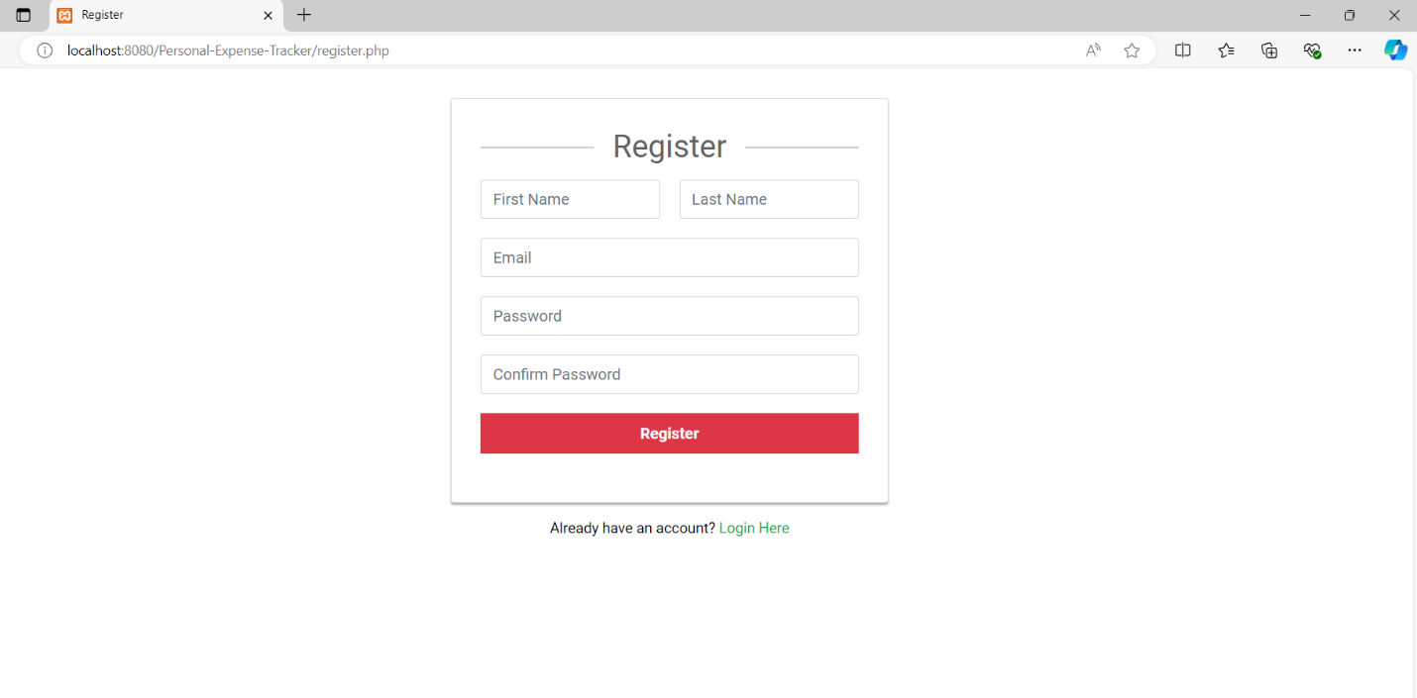

# 2.2.2 Login

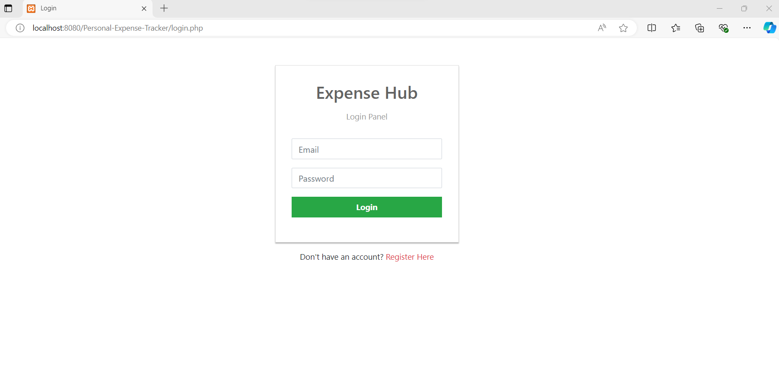

# 2.1.3 Dashboard

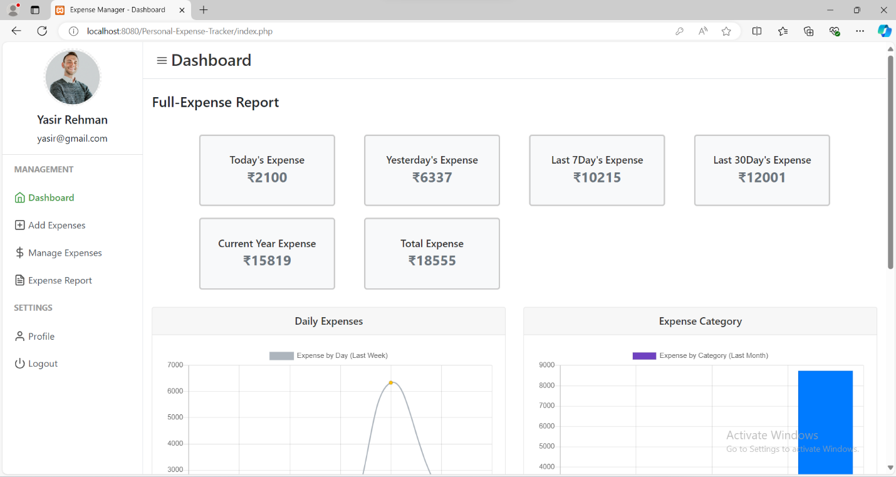

# 2.1.3 Dashboard Visualizations- Charts

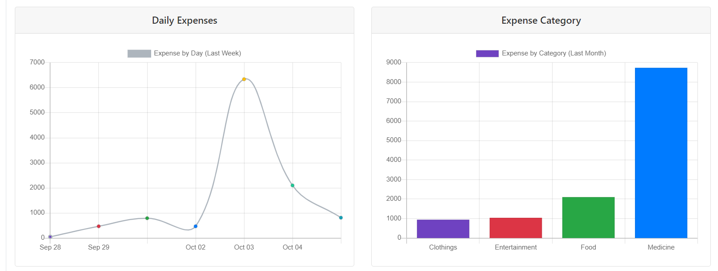

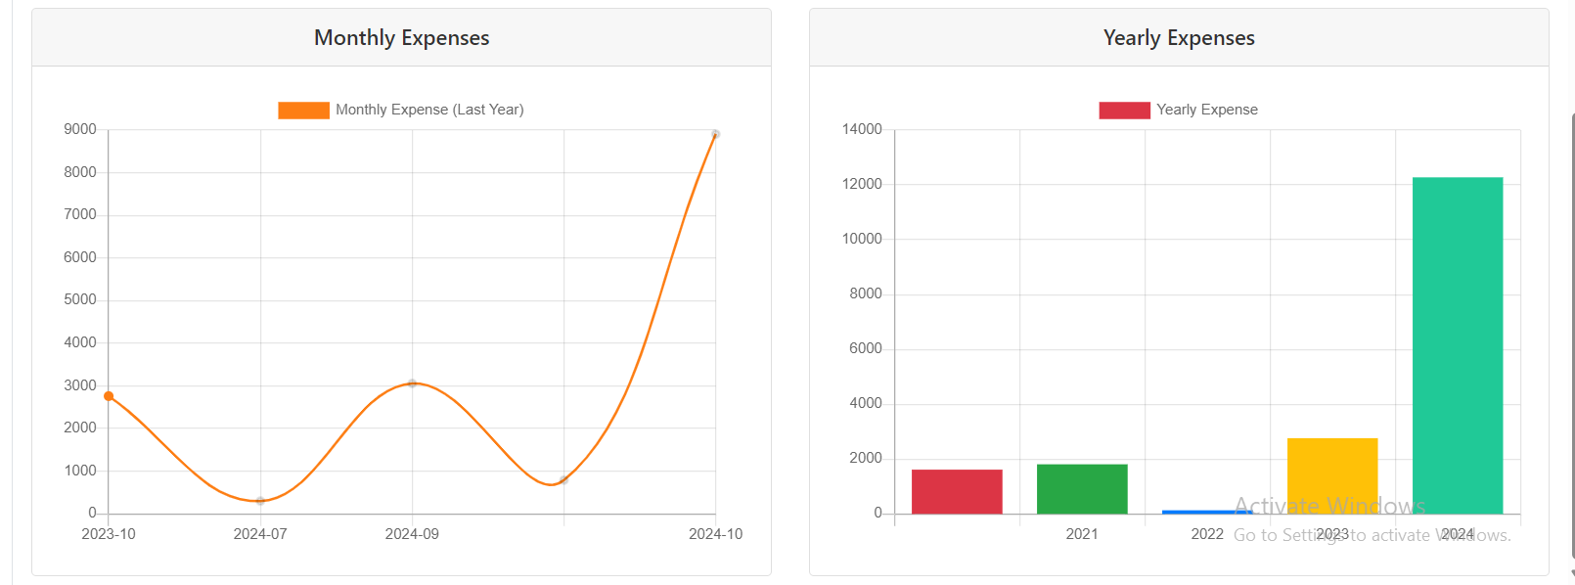

# 2.1.4 Add Expense

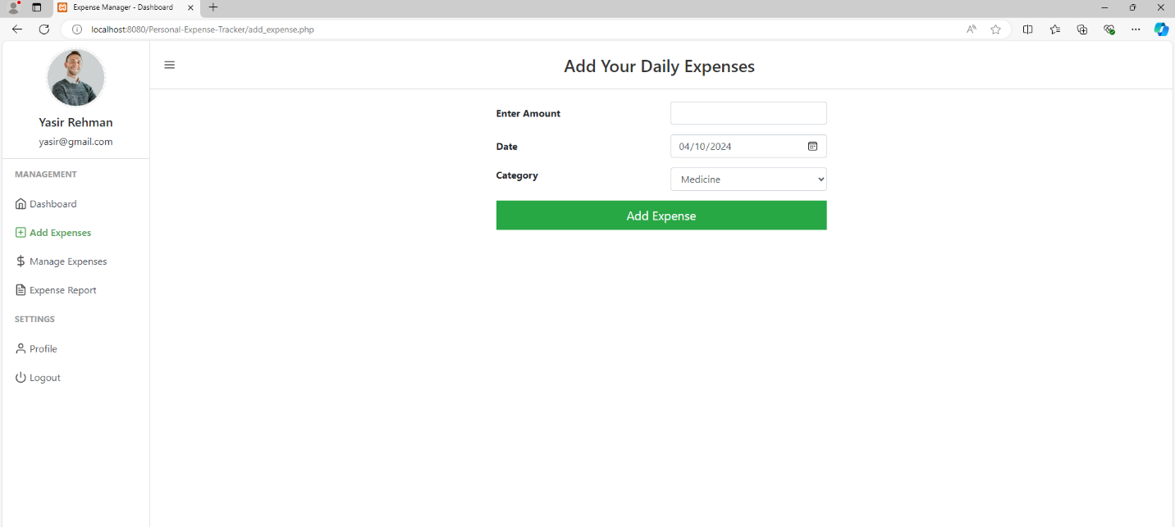

# 2.1.5 Manage Expenses

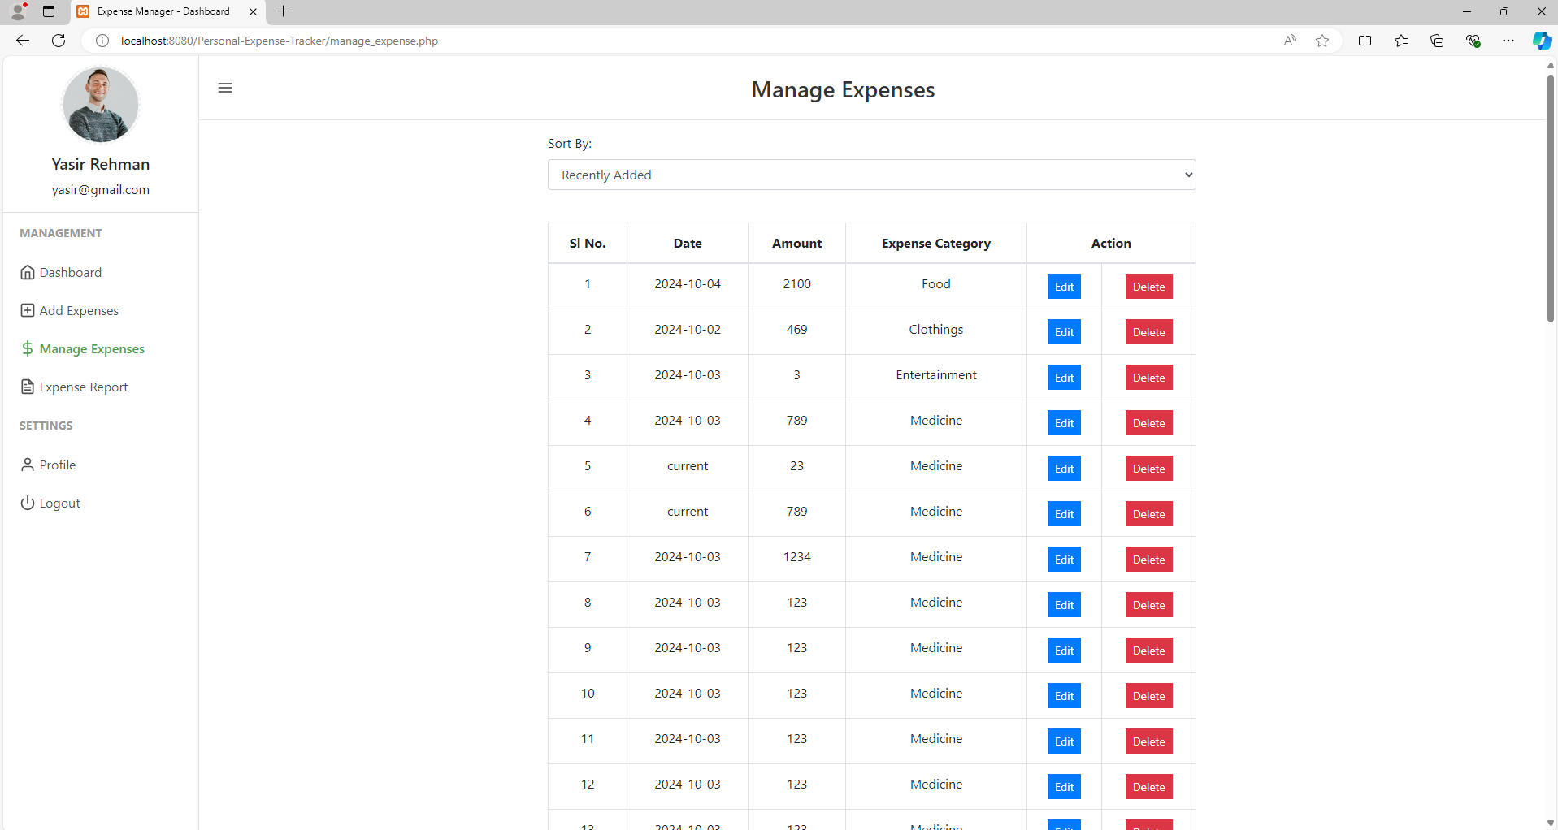

# 2.1.6 Update Expense

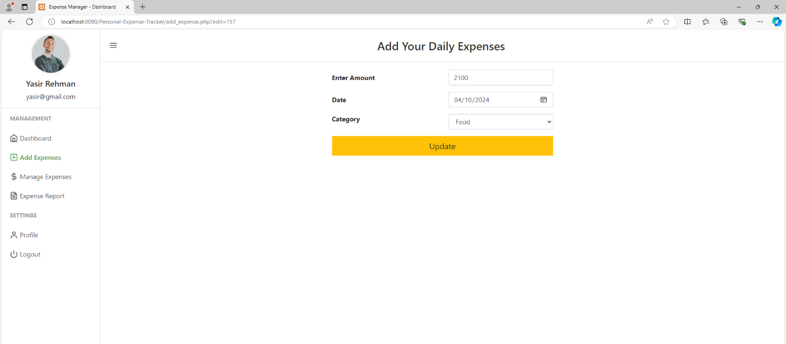

# 2.1.7 Delete Expense

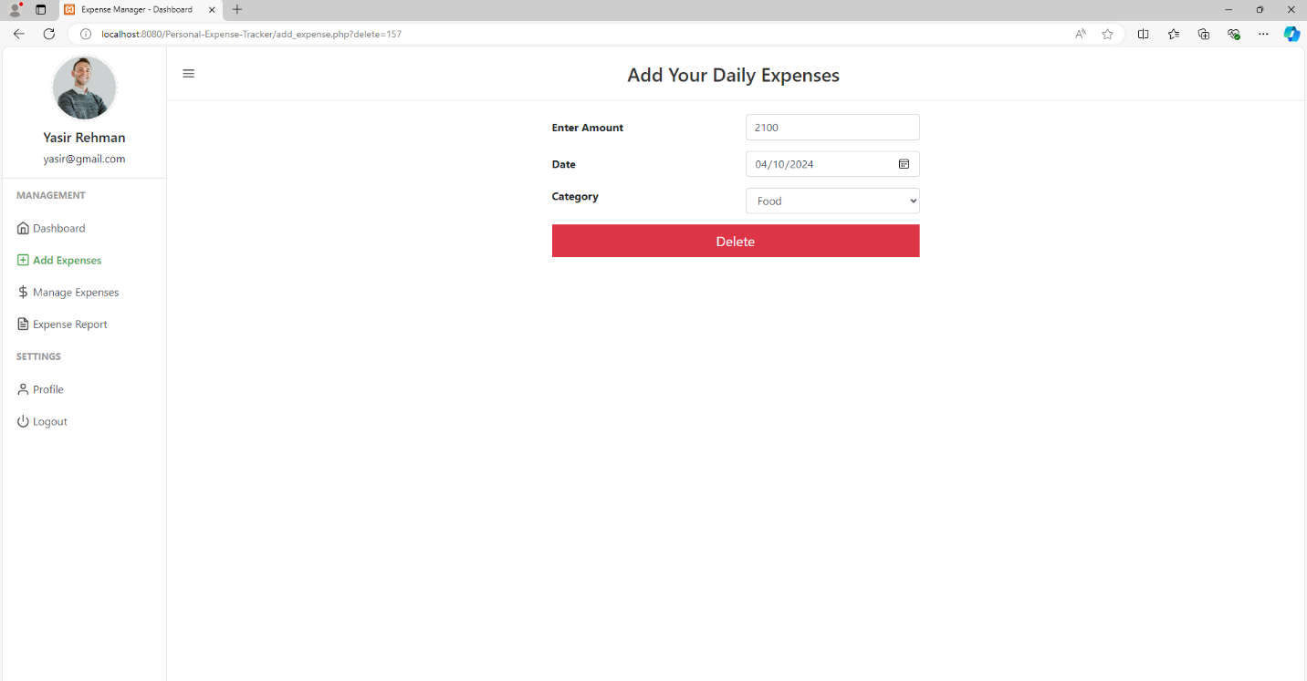

# 2.1.8 Expense Report

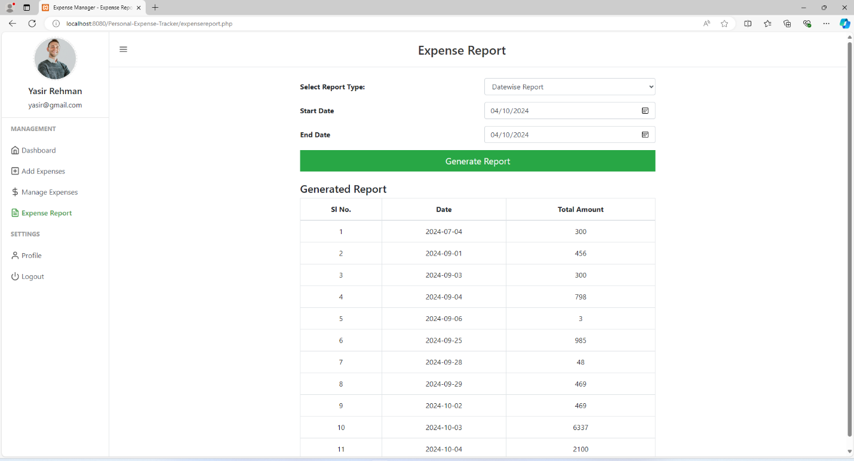

# 2.1.9 Update Profile

